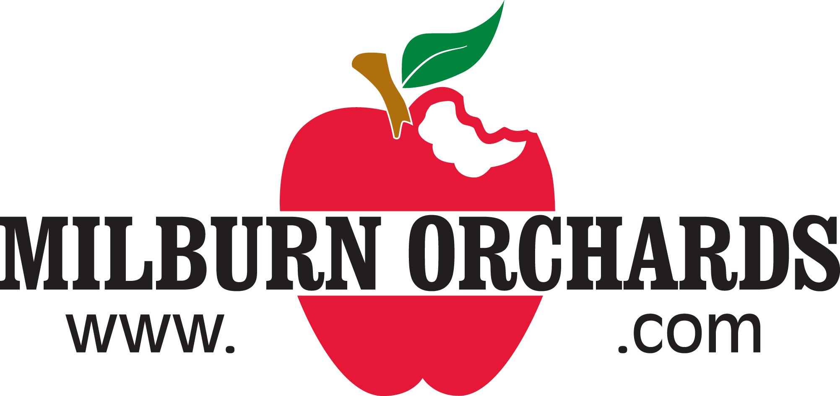

Social Media Policy

Milburn Orchards acknowledges that its employees have the right to contribute to public communication on websites, blogs, and social networking sites. However inappropriate behavior on such sites has the potential to cause damage to Milburns as well as its employees, clients, business partners, and/or suppliers.

DEFINITION OF SOCIAL MEDIA
“Social media” means communications and posts of information, images, photographs, or other online content whether on a website, blog, social networking website, app, or other online destination that hosts user-submitted content. Throughout this Policy, we will refer to your activity on such sites as “post” or “posting.”

Examples of social media include: Facebook, YouTube, Pinterest, Instagram, Snapchat, Twitter, LinkedIn, WordPress, Tumblr, Reddit, personal websites, message board, chat rooms, online forums, and review sharing sites.

USE OF SOCIAL MEDIA BY ASSOCIATES
If you would like to promote Milburn Orchards or our products, offerings, activities, etc. through social media on your own time, here are some ways that you can do that:
- Like, follow, etc. our social media pages and encourage customers, friends, and family to do the same
- Like, share, and comment on our social media page posts

RULES
All employees of Milburn Orchards must refrain from posting, reposting, sharing, sending, forwarding, or using, in any way, any inappropriate material including but not limited to material that:
- Has the potential to bring Milburn Orchards into disrepute
- Gives away or discusses confidential information, business practices, policies, projects, etc.
- Could be viewed as derogatory towards fellow employees, customers, managers, owners, etc.
- Undermines effectiveness or productivity at work (e.g. excessive use while not on break)
- Provides your Milburn Orchards affiliation on posts related to the political process, a political party, or candidate
- Promotes illegal activity including but not limited to, illegal drug use, illegally selling or buying of drugs, underage drinking, etc.

All employees of Milburn Orchards must comply with this policy. Any breach of this policy will be treated as a serious matter and may result in disciplinary action including termination of employment.

PLEASE READ THESE IMPORTANT DISCLAIMERS
Consistent with your rights under Section 7 of the National Labor Relations Act (and other applicable laws), nothing in our Social Media Policy limit’s an employee’s right to free speech, or to communicate or organize with others about concerns with your terms and conditions of employment, our labor practices or policies or other work-related issues.

Any sort of conduct which is prohibited under Milburn Orchards’ policies is also prohibited in any form of Social Media. Milburn Orchards is not responsible for your conduct or any errors or damages you may cause, or be subject to, related to your Social Media account ownership, privacy settings, or your posts and may hold you liable for violations of these guidelines. We also reserve the right to remove any posts that violate our policies.

COMPLIANCE
If you have any questions or comments about the Policy, or using Social Media responsibly, please direct your comments to an owner of Milburn Orchards or the Public Relations and Marketing Coordinator, Olivia Palmeri.

If you feel that anyone associated with Milburn Orchards has engaged in inappropriate conduct through the use of Social Media, you must immediately raise your concerns with an owner or the Public Relations and Marketing Coordinator. You will not be subject to retaliation, intimidation, or discipline as a result of a report of a violation of this policy.
By signing this document, you hereby declare you have read and understand the statements above and agree to adhere to all policies set forth in the Social Media Policy for Milburn Orchards.

